Jenkins Pipeline configuration

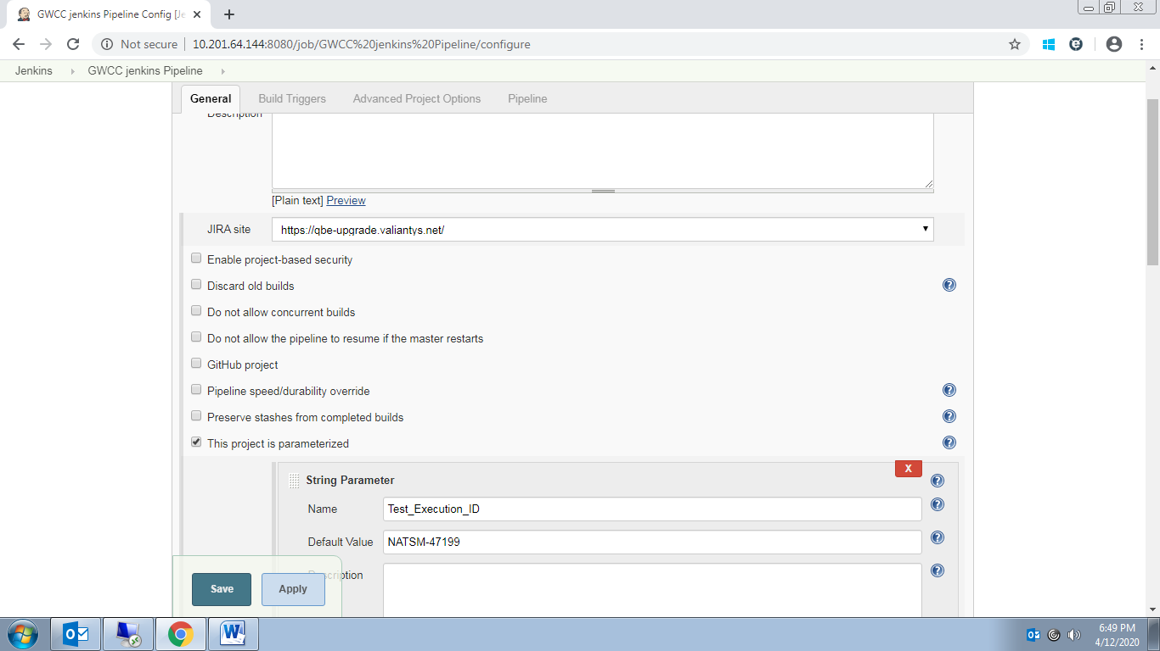

Groovy script

pipeline {

agent any

stages {

stage('Run Tests in Parallel') {

parallel {

stage ('Build Jobs_1')

{

agent {

node { label "anyNode" }

}

steps

{

script

{

try

{

//echo "Hello World!"

//bat 'echo %PATH%'

bat 'echo %COMPUTERNAME%'

bat 'taskkill /f /im iexplore.exe'

bat 'taskkill /f /im IEDriverServer.exe'

}

catch (Exception e) {

echo "Stage failed, but we continue"

}

TestExeID = env.Test_Execution_ID

build job: 'QBE_NA_GWCC_BATCH_1',parameters: [[$class:'StringParameterValue', name: 'testExeID', value: TestExeID],[$class:'StringParameterValue', name: 'testngxml', value: 'testng_Regression.xml']],wait: false

bat 'echo %COMPUTERNAME%==%JAVA_HOME%==%MAVEN_HOME%==%OS%'

}

}

}

stage ('Build Jobs_2') {

agent {

node { label "anyNode" }

}

steps {

script{

try{

//echo "Hello World!"

//bat 'echo %PATH%'

bat 'echo %COMPUTERNAME%'

bat 'taskkill /f /im iexplore.exe'

bat 'taskkill /f /im IEDriverServer.exe'

}

catch (Exception e) {

echo "Stage failed, but we continue"

}

TestExeID = env.Test_Execution_ID

build job: 'QBE_NA_GWCC_BATCH_2',parameters: [[$class:'StringParameterValue', name: 'testExeID', value: TestExeID],[$class:'StringParameterValue', name: 'testngxml', value: 'testng_Regression.xml']],wait: false

bat 'echo %COMPUTERNAME%==%JAVA_HOME%==%MAVEN_HOME%==%OS%'

}

}

}

stage ('Build Jobs_3') {

agent {

node { label "anyNode" }

}

steps {

script{

try{

//echo "Hello World!"

//bat 'echo %PATH%'

bat 'echo %COMPUTERNAME%'

bat 'taskkill /f /im iexplore.exe'

bat 'taskkill /f /im IEDriverServer.exe'

}

catch (Exception e) {

echo "Stage failed, but we continue"

}

TestExeID = env.Test_Execution_ID

build job: 'QBE_NA_GWCC_BATCH_3',parameters: [[$class:'StringParameterValue', name: 'testExeID', value: TestExeID],[$class:'StringParameterValue', name: 'testngxml', value: 'testng_Regression.xml']],wait: false

bat 'echo %COMPUTERNAME%==%JAVA_HOME%==%MAVEN_HOME%==%OS%'

}

}

}

stage ('Build Jobs_4') {

agent {

node { label "anyNode" }

}

steps {

script{

try{

//echo "Hello World!"

//bat 'echo %PATH%'

bat 'echo %COMPUTERNAME%'

bat 'taskkill /f /im iexplore.exe'

bat 'taskkill /f /im IEDriverServer.exe'

}

catch (Exception e) {

echo "Stage failed, but we continue"

}

TestExeID = env.Test_Execution_ID

build job: 'QBE_NA_GWCC_BATCH_4',parameters: [[$class:'StringParameterValue', name: 'testExeID', value: TestExeID],[$class:'StringParameterValue', name: 'testngxml', value: 'testng_Regression.xml']],wait: false

bat 'echo %COMPUTERNAME%==%JAVA_HOME%==%MAVEN_HOME%==%OS%'

}

}

}

stage ('Build Jobs_5') {

agent {

node { label "anyNode" }

}

steps {

script{

try{

//echo "Hello World!"

//bat 'echo %PATH%'

bat 'echo %COMPUTERNAME%'

bat 'taskkill /f /im iexplore.exe'

bat 'taskkill /f /im IEDriverServer.exe'

}

catch (Exception e) {

echo "Stage failed, but we continue"

}

TestExeID = env.Test_Execution_ID

build job: 'QBE_NA_GWCC_BATCH_5',parameters: [[$class:'StringParameterValue', name: 'testExeID', value: TestExeID],[$class:'StringParameterValue', name: 'testngxml', value: 'testng_Regression.xml']],wait: false

bat 'echo %COMPUTERNAME%==%JAVA_HOME%==%MAVEN_HOME%==%OS%'

}

}

}

stage ('Build Jobs_6') {

steps {

script{

try{

//echo "Hello World!"

//bat 'echo %PATH%'

bat 'echo %COMPUTERNAME%'

bat 'taskkill /f /im iexplore.exe'

bat 'taskkill /f /im IEDriverServer.exe'

}

catch (Exception e) {

echo "Stage failed, but we continue"

}

TestExeID = env.Test_Execution_ID

build job: 'QBE_NA_GWCC_BATCH_6',parameters: [[$class:'StringParameterValue', name: 'testExeID', value: TestExeID],[$class:'StringParameterValue', name: 'testngxml', value: 'testng_Regression.xml']],wait: false

bat 'echo %COMPUTERNAME%==%JAVA_HOME%==%MAVEN_HOME%==%OS%'

}

}

}

stage ('Build Jobs_7') {

steps {

script{

try{

//echo "Hello World!"

//bat 'echo %PATH%'

bat 'echo %COMPUTERNAME%'

bat 'taskkill /f /im iexplore.exe'

bat 'taskkill /f /im IEDriverServer.exe'

}

catch (Exception e) {

echo "Stage failed, but we continue"

}

TestExeID = env.Test_Execution_ID

build job: 'QBE_NA_GWCC_BATCH_7',parameters: [[$class:'StringParameterValue', name: 'testExeID', value: TestExeID],[$class:'StringParameterValue', name: 'testngxml', value: 'testng_Regression.xml']],wait: false

bat 'echo %COMPUTERNAME%==%JAVA_HOME%==%MAVEN_HOME%==%OS%'

}

}

}

stage ('Build Jobs_8') {

steps {

script{

try{

//echo "Hello World!"

//bat 'echo %PATH%'

bat 'echo %COMPUTERNAME%'

bat 'taskkill /f /im iexplore.exe'

bat 'taskkill /f /im IEDriverServer.exe'

}

catch (Exception e) {

echo "Stage failed, but we continue"

}

TestExeID = env.Test_Execution_ID

build job: 'QBE_NA_GWCC_BATCH_8',parameters: [[$class:'StringParameterValue', name: 'testExeID', value: TestExeID],[$class:'StringParameterValue', name: 'testngxml', value: 'testng_Regression.xml']],wait: false

bat 'echo %COMPUTERNAME%==%JAVA_HOME%==%MAVEN_HOME%==%OS%'

}

}

}

stage ('Build Jobs_9') {

steps {

script{

try{

//echo "Hello World!"

//bat 'echo %PATH%'

bat 'echo %COMPUTERNAME%'

bat 'taskkill /f /im iexplore.exe'

bat 'taskkill /f /im IEDriverServer.exe'

}

catch (Exception e) {

echo "Stage failed, but we continue"

}

TestExeID = env.Test_Execution_ID

build job: 'QBE_NA_GWCC_BATCH_9',parameters: [[$class:'StringParameterValue', name: 'testExeID', value: TestExeID],[$class:'StringParameterValue', name: 'testngxml', value: 'testng_Regression.xml']],wait: false

bat 'echo %COMPUTERNAME%==%JAVA_HOME%==%MAVEN_HOME%==%OS%'

}

}

}

stage ('Build Jobs_10') {

steps {

script{

try{

//echo "Hello World!"

//bat 'echo %PATH%'

bat 'echo %COMPUTERNAME%'

bat 'taskkill /f /im iexplore.exe'

bat 'taskkill /f /im IEDriverServer.exe'

}

catch (Exception e) {

echo "Stage failed, but we continue"

}

TestExeID = env.Test_Execution_ID

build job: 'QBE_NA_GWCC_BATCH_10',parameters: [[$class:'StringParameterValue', name: 'testExeID', value: TestExeID],[$class:'StringParameterValue', name: 'testngxml', value: 'testng_Regression.xml']],wait: false

bat 'echo %COMPUTERNAME%==%JAVA_HOME%==%MAVEN_HOME%==%OS%'

}

}

}

}

}

}

}